Q. Demonstrate FTP Server in Packet Tracer.

Aim: To configure an FTP server and test file transfer between server and clients in the network.
Devices Needed:
1 Server (FTP Server)
- Switch
- PCs (FTP Clients) Connection :
Connect all devices to the switch using copper straight-through cables

Topology:
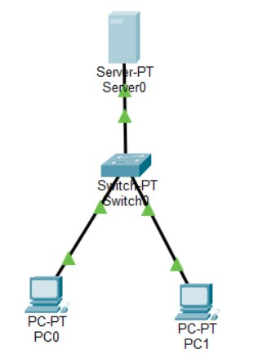

Code:
Server Configuration (FTP):
1.Click on Server → Services tab → FTP
2.FTP Server Settings: FTP Service: ON

3.Add User Account: Username: admin
Password: cisco

Check all permissions: Read/Write/List/Delete/Rename

Click Add
Server IP Configuration:
IP Address: 192.168.1.5
Subnet Mask: 255.255.255.0 Default Gateway: 192.168.1.1 PC1 Configuration:

IP Address: 192.168.1.10
Subnet Mask: 255.255.255.0 Default Gateway: 192.168.1.1 PC2 Configuration:
IP Address: 192.168.1.11
Subnet Mask: 255.255.255.0
Default Gateway: 192.168.1.1
Create Test File on PC1
1.Click on PC1 → Desktop tab → Text Editor
2.Type: This is a test file for FTP transfer
3.Save as: upload_test.txt Verification: In PC Command Prompt PC1 FTP Commands:
C:\>ftp 192.168.1.5
Username: admin Password: cisco ftp> dir ftp> put upload_test.txt ftp> dir ftp> get welcome.txt ftp> delete notes.txt ftp> quit

PC2 FTP Commands:
C:\>ftp 192.168.1.5
Username: admin Password: cisco ftp> dir ftp> get upload_test.txt ftp> rename upload_test.txt downloaded_file.txt ftp> dir ftp> quit
Ping Test (Both PCs):
C:\>ping 192.168.1.5

PC1 FTP Session:

Output:
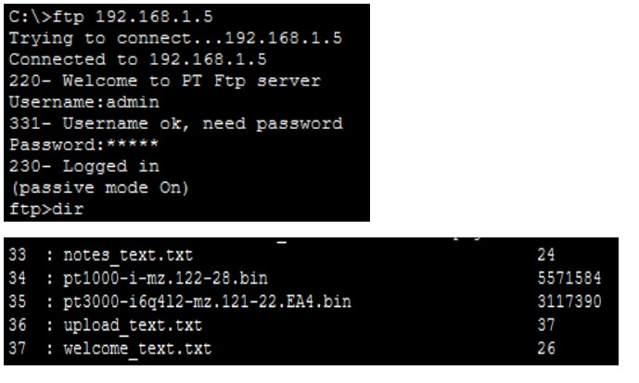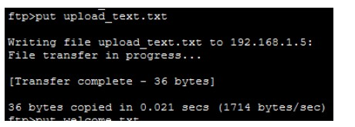

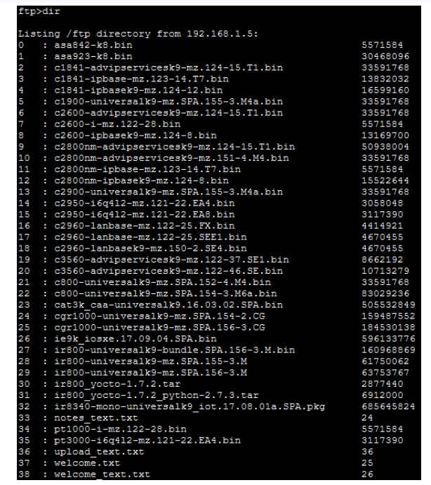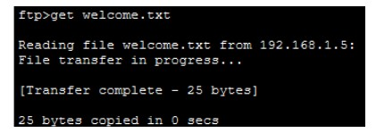

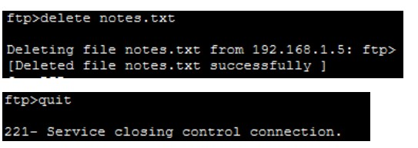

Ping Test Results:
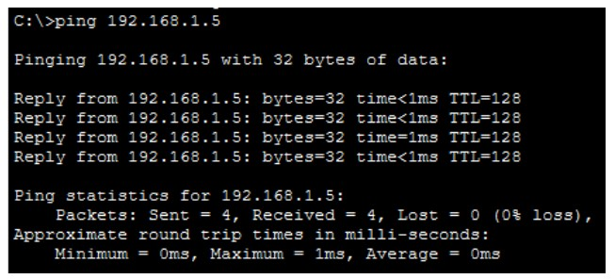

PC2 FTP Session:
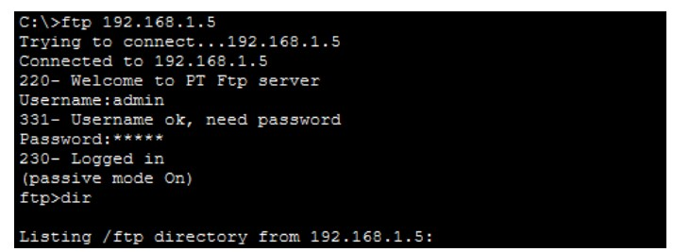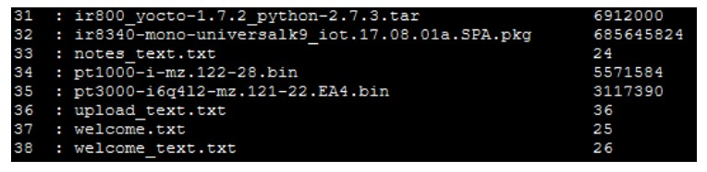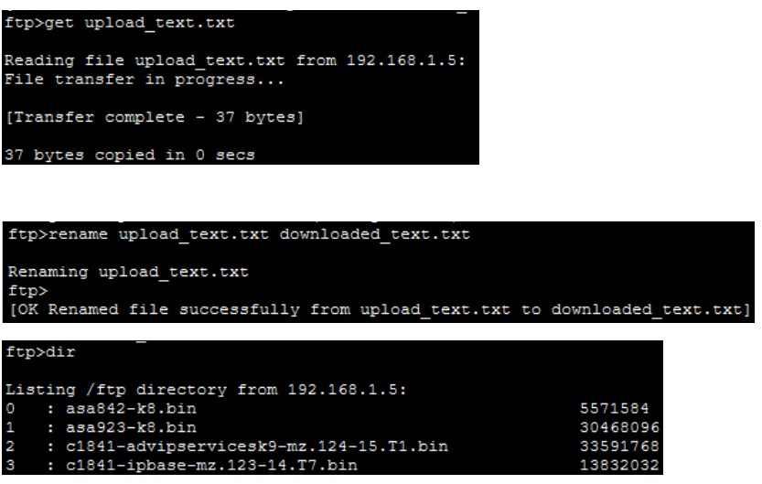

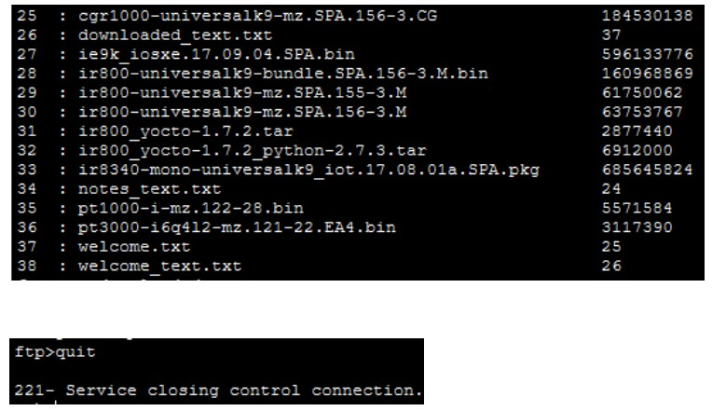

Ping Test Results:
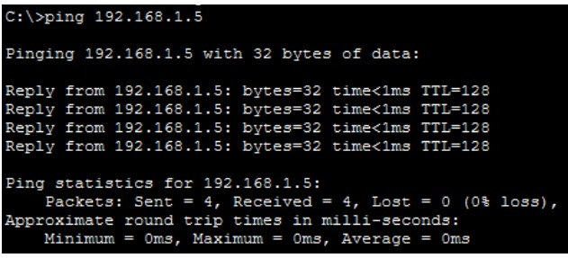

Conclusion: The FTP server has been configured successfully

